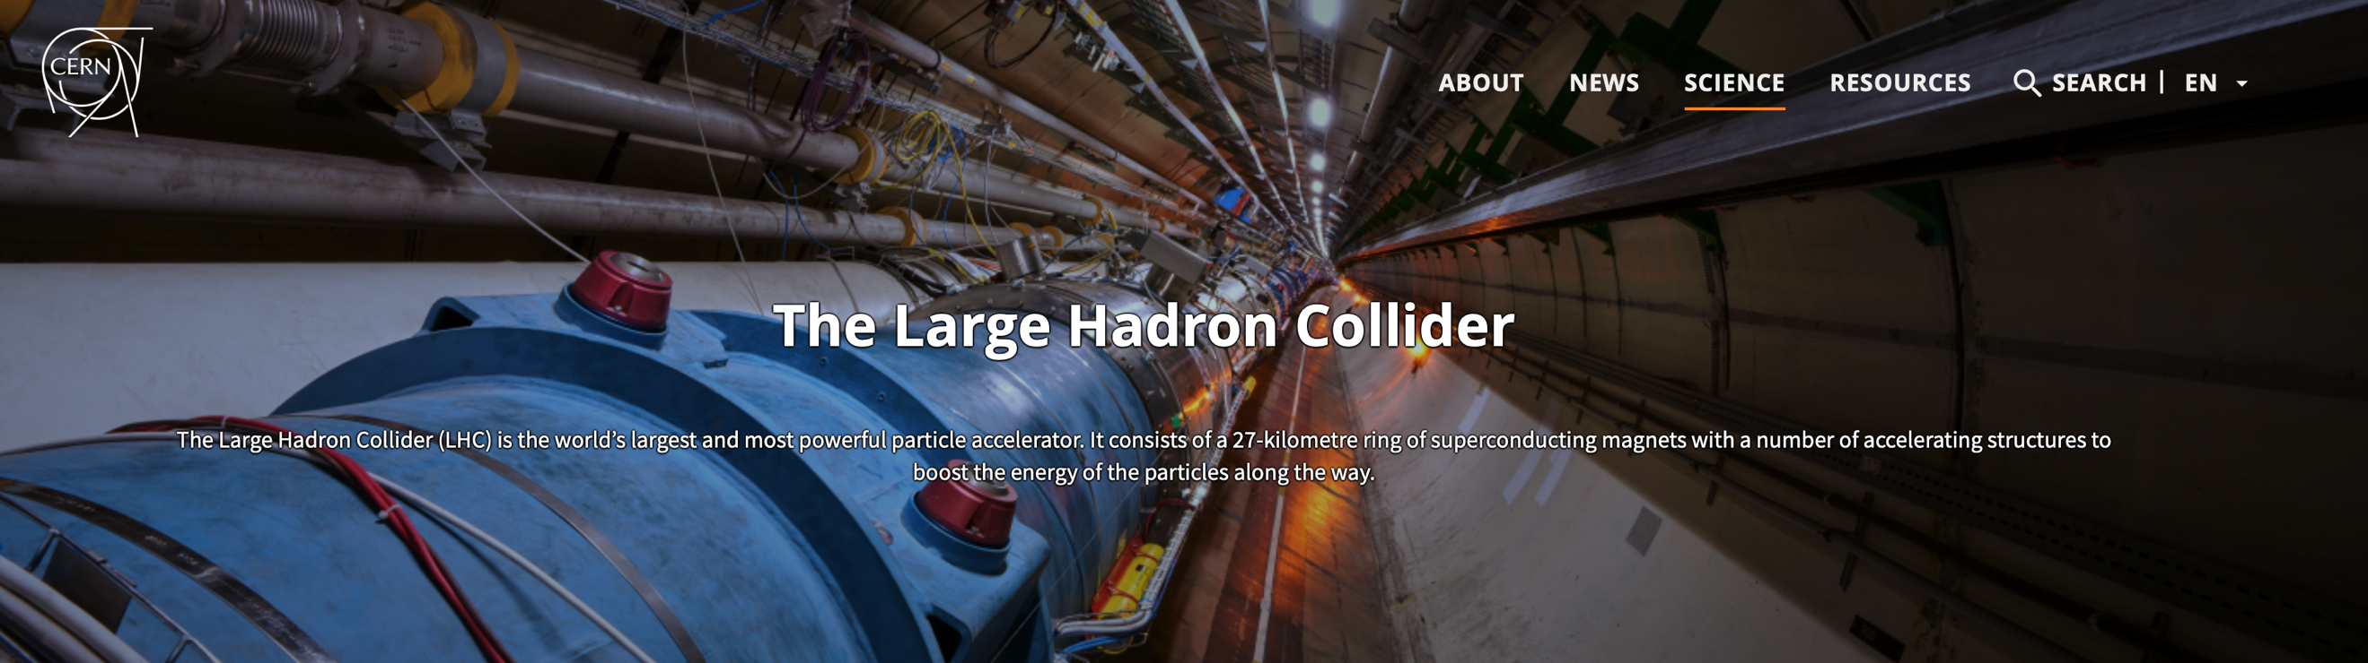

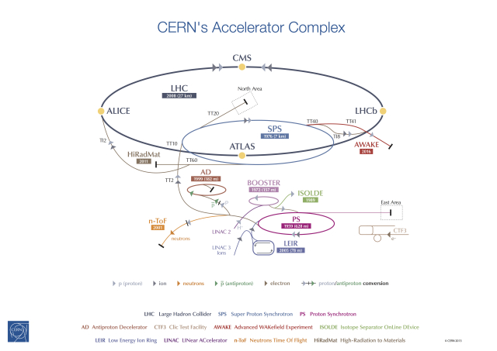

There's more to CERN than the Large Hadron Collider. A series of accelerators work together to push particles to nearly the speed of light

The CERN accelerator complex
The accelerator complex at CERN is a succession of machines that accelerate particles to increasingly higher energies. Each machine boosts the energy of a beam of particles, before injecting the beam into the next machine in the sequence. In the Large Hadron Collider (LHC) – the last element in this chain – particle beams are accelerated up to the record energy of 6.5 TeV per beam. Most of the other accelerators in the chain have their own experimental halls where beams are used for experiments at lower energies.
The proton source is a simple bottle of hydrogen gas. An electric field is used to strip hydrogen atoms of their electrons to yield protons. Linac 2, the first accelerator in the chain, accelerates the protons to the energy of 50 MeV. The beam is then injected into the Proton Synchrotron Booster (PSB), which accelerates the protons to 1.4 GeV, followed by the Proton Synchrotron (PS), which pushes the beam to 25 GeV. Protons are then sent to the Super Proton Synchrotron (SPS) where they are accelerated to 450 GeV.
The protons are finally transferred to the two beam pipes of the LHC. The beam in one pipe circulates clockwise while the beam in the other pipe circulates anticlockwise. It takes 4 minutes and 20 seconds to fill each LHC ring, and 20 minutes for the protons to reach their maximum energy of 6.5 TeV. Beams circulate for many hours inside the LHC beam pipes under normal operating conditions. The two beams are brought into collision inside four detectors – ALICE, ATLAS, CMS and LHCb – where the total energy at the collision point is equal to 13 TeV.
The accelerator complex includes the Antiproton Decelerator and the Online Isotope Mass Separator (ISOLDE) facility, and the Compact Linear Collider test area, as well as the neutron time-of-flight facility (nTOF). It also previously fed the CERN Neutrinos to Gran Sasso (CNGS) project.
Protons are not the only particles accelerated in the LHC. Lead ions for the LHC start from a source of vaporised lead and enter Linac 3 before being collected and accelerated in the Low Energy Ion Ring (LEIR). They then follow the same route to maximum energy as the protons.

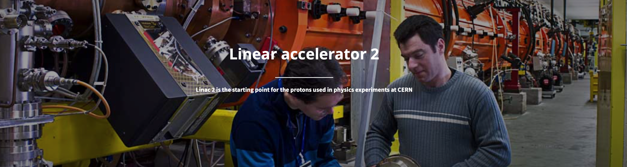

Linear accelerator 2 (Linac 2) is the starting point for the protons used in experiments at CERN. Linear accelerators use radiofrequency cavities to charge cylindrical conductors. The protons pass through the conductors, which are alternately charged positive or negative. The conductors behind them push the particles and the conductors ahead of them pull, causing the particles to accelerate. Small quadrupole magnets ensure that the protons remain in a tight beam.
The proton source is a bottle of hydrogen gas at one end of Linac 2. The hydrogen is passed through an electric field to strip off its electrons, leaving only protons to enter the accelerator. By the time they reach the other end, the protons have reached the energy of 50 MeV and gained 5% in mass. They then enter the Proton Synchrotron Booster, the next step in CERN's accelerator chain, which takes them to a higher energy.
The proton beams are pulsed from the hydrogen bottle for up to 100 microseconds per pulse. The pulses are repeated again and again until enough protons are produced.
Linac 2 started up in 1978, when it replaced Linac 1. It was originally built to allow higher intensity beams for the accelerators that follow it in CERN's accelerator complex. Linac 2 will be replaced by Linac 4 in 2020.

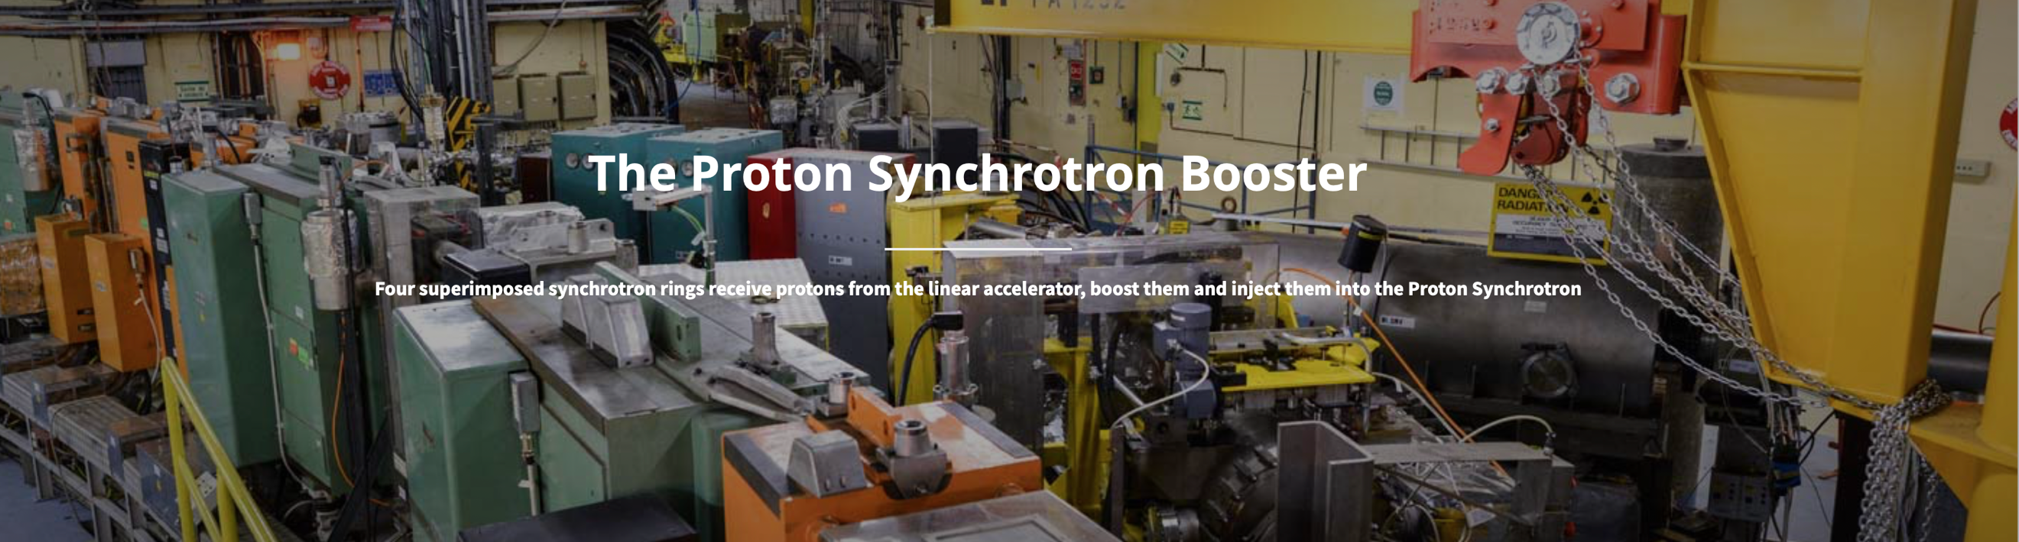

The Proton Synchrotron Booster is made up of four superimposed synchrotron rings that receive beams of protons from the linear accelerator Linac 2 at 50 MeV and accelerate them to 1.4 GeV for injection into the Proton Synchrotron (PS).
Before the Booster received its first beams on 26 May 1972, protons were injected directly from the linac into the PS, where they were accelerated to 26 GeV. The low injection energy of 50 MeV limited the number of protons the PS could accept. The Booster allows the PS to accept over 100 times more protons, which greatly enhances the beam's use for experiments.

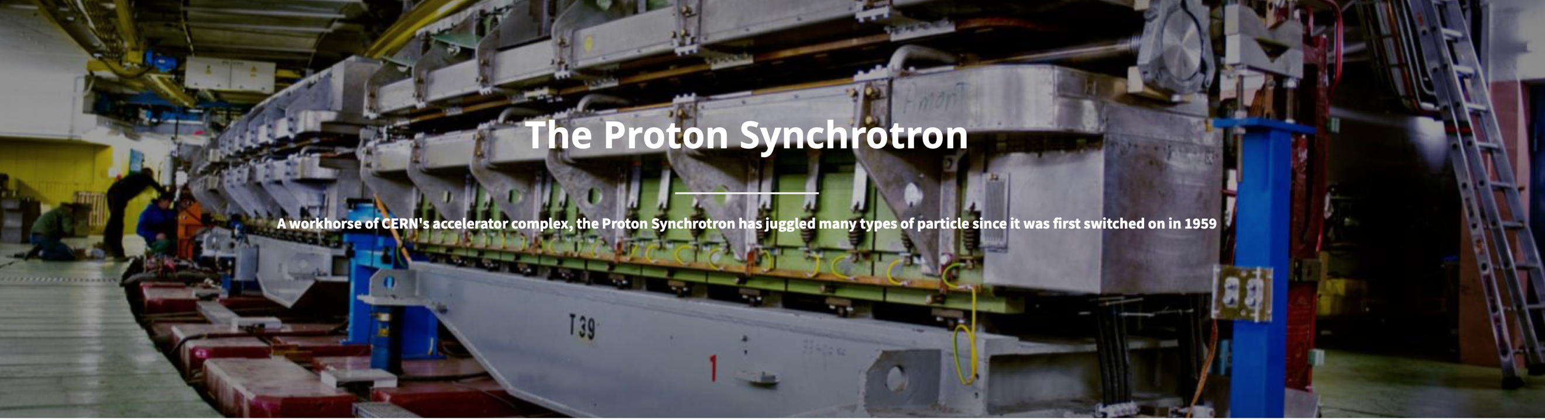

The Proton Synchrotron (PS) is a key component in CERN’s accelerator complex, where it usually accelerates either protons delivered by the Proton Synchrotron Booster or heavy ions from the Low Energy Ion Ring (LEIR). In the course of its history it has juggled many different kinds of particles, feeding them directly to experiments or to more powerful accelerators.
The PS first accelerated protons on 24 November 1959, becoming for a brief period the world’s highest energy particle accelerator. The PS was CERN’s first synchrotron. It was initially CERN's flagship accelerator, but when the laboratory built new accelerators in the 1970s, the PS’s principal role became to supply particles to the new machines. Over the years, it has undergone many modifications and the intensity of its proton beam has increased a thousandfold.
With a circumference of 628 metres, the PS has 277 conventional (room-temperature) electromagnets, including 100 dipoles to bend the beams round the ring. The accelerator operates at up to 25 GeV. In addition to protons, it has accelerated alpha particles (helium nuclei), oxygen and sulphur nuclei, electrons, positrons and antiprotons.

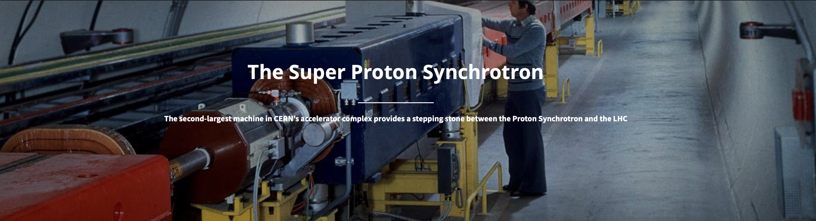

The Super Proton Synchrotron (SPS) is the second-largest machine in CERN’s accelerator complex. Measuring nearly 7 kilometres in circumference, it takes particles from the Proton Synchrotron and accelerates them to provide beams for the Large Hadron Collider, the NA61/SHINE and NA62 experiments, the COMPASS experiment. It will also soon feed the AWAKE experiment which aims to test new techniques for accelerating particles.
The SPS became the workhorse of CERN’s particle physics programme when it switched on in 1976. Research using SPS beams has probed the inner structure of protons, investigated nature’s preference for matter over antimatter, looked for matter as it might have been in the first instants of the universe and searched for exotic forms of matter. A major highlight came in 1983 with the Nobel-prize-winning discovery of W and Z particles, with the SPS running as a proton-antiproton collider.
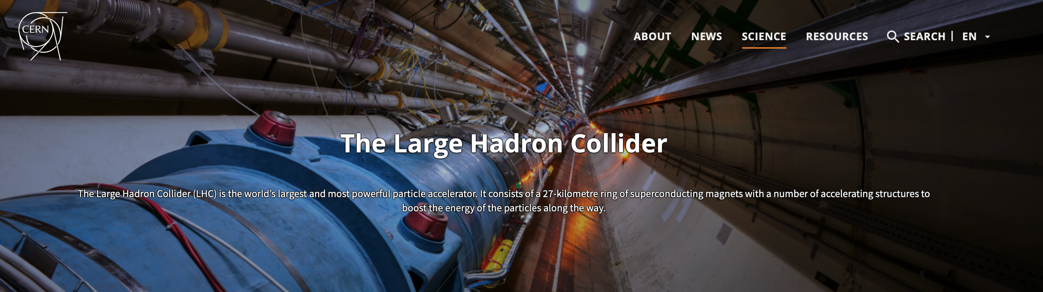
The SPS operates at up to 450 GeV. It has 1317 conventional (room-temperature) electromagnets, including 744 dipoles to bend the beams round the ring. The accelerator has handled many different kinds of particles: sulphur and oxygen nuclei, electrons, positrons, protons and antiprotons.

The Large Hadron Collider (LHC) is the world’s largest and most powerful particle accelerator. It first started up on 10 September 2008, and remains the latest addition to CERN’s accelerator complex. The LHC consists of a 27-kilometre ring of superconducting magnets with a number of accelerating structures to boost the energy of the particles along the way.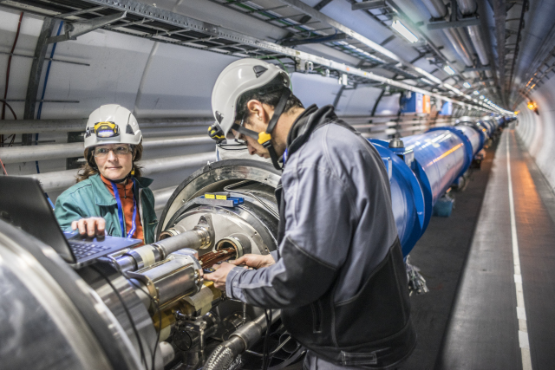(Image: Anna Pantelia/CERN)
Inside the accelerator, two high-energy particle beams travel at close to the speed of light before they are made to collide. The beams travel in opposite directions in separate beam pipes – two tubes kept at ultrahigh vacuum. They are guided around the accelerator ring by a strong magnetic field maintained by superconducting electromagnets. The electromagnets are built from coils of special electric cable that operates in a superconducting state, efficiently conducting electricity without resistance or loss of energy. This requires chilling the magnets to -271.3°C – a temperature colder than outer space. For this reason, much of the accelerator is connected to a distribution system of liquid helium, which cools the magnets, as well as to other supply services.
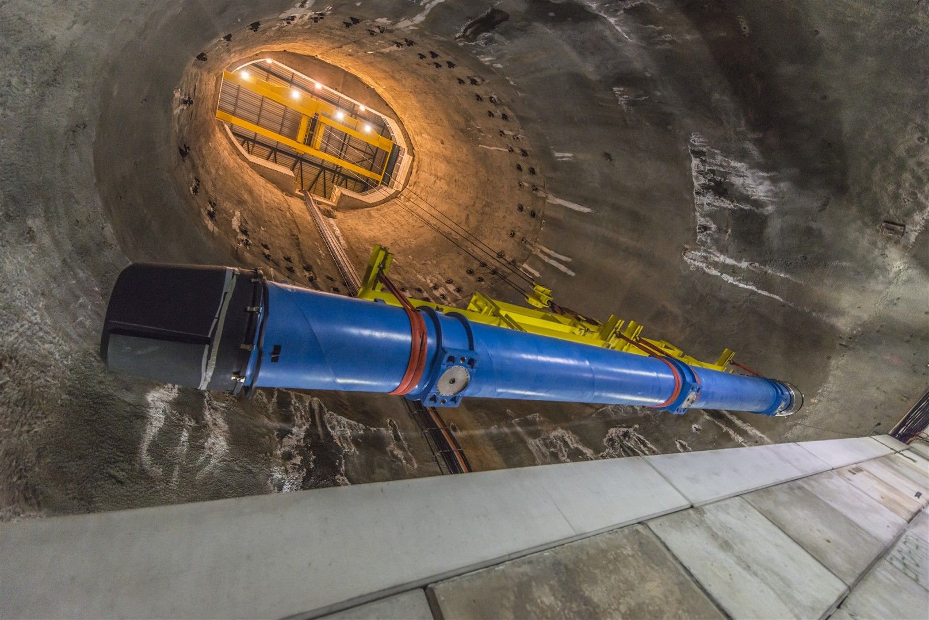Replacing one of the LHC's dipole magnets (Image: Maximilien Brice/CERN)

Thousands of magnets of different varieties and sizes are used to direct the beams around the accelerator. These include 1232 dipole magnets 15 metres in length which bend the beams, and 392 quadrupole magnets, each 5–7 metres long, which focus the beams. Just prior to collision, another type of magnet is used to "squeeze" the particles closer together to increase the chances of collisions. The particles are so tiny that the task of making them collide is akin to firing two needles 10 kilometres apart with such precision that they meet halfway.
All the controls for the accelerator, its services and technical infrastructure are housed under one roof at the CERN Control Centre. From here, the beams inside the LHC are made to collide at four locations around the accelerator ring, corresponding to the positions of four particle detectors – ATLAS, CMS, ALICE and LHCb.

The Control Centre
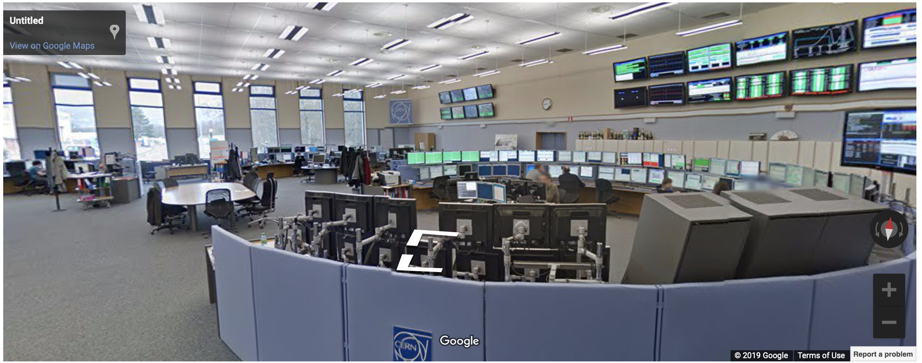
The CERN Control Centre combines control rooms for the laboratory’s accelerators, the cryogenic distribution system and the technical infrastructure. It holds 39 operation stations for four different areas – the LHC, the SPS, the PS complex and the technical infrastructure.

