Inclusive Jet Cross Sections in Neutral Current DIS Events in the Breit Frame
Jeff Standage
York University
(On behalf of the ZEUS Collaboration)
Email: standage@mail.desy.de
Abstract. Inclusive jet differential cross sections have been measured in neutral current deep inelastic scattering e⁺p collisions for photon virtualities Q² > 125 GeV² with the ZEUS detector at HERA using an integrated luminosity of 65 pb⁻¹. Jets were identified in the Breit frame using the longitudinally invariant k_{T}-cluster algorithm. Measurements of differential inclusive jet cross sections are presented as a function of jet transverse energy, E_{T}^{B}(jet), jet pseudorapidity, η^{B}, and Q², for jets with E_{T}^{B}(jet) > 8 GeV. Next-to-leading-order (NLO) QCD calculations describe well the measurements. An NLO QCD analysis of the differential cross sections allows a precise determination of α_{s}(M_{Z}).
Keywords: DIS Inclusive Jets Breit
PACS: 12.38.Qk

1. Introduction
Measurements of jet cross sections are a well-established tool for QCD studies. In particular, inclusive jet cross sections at high photon virtuality, Q², are sensitive to the strong coupling constant, α_{s}, and can be used to determine this quantity. Several measurements of this quantity have already been performed at HERA [1] with results competitive with the world average [2]. ZEUS has also started to include jet cross sections in their global QCD fits, reducing substantially the uncertainty on the gluon density in the high-x region [3].
In this paper, a report is made of a new ZEUS measurement of the inclusive jet cross section at high Q² > 125 GeV in 1999-2000 e⁺p data. Jets were reconstructed using the longitudinally invariant inclusive k_{T}-cluster algorithm [4] in the Breit frame. The measurement was made differentially in the transverse energy of the jet in the Breit frame, E_{T}^{B}, in Q² and in the jet pseudorapidity in the Breit frame, η^{B}. The measurements are compared to next-to-leading order QCD calculations.

2. Theoretical Predictions
The data are compared to NLO QCD calculations using the program DISENT [5]. These calculations interface NLO matrix elements with proton parton density functions (PDFs), in this case the MRST99 [6] parameterization was used, to make parton level predictions for the cross sections. The factorization scale was set to Q and the renormalization scale was set to E_{T}^{B}(jet). The number of flavours was set to five and α_{s}(M_{Z}) was set to 0.1175. The calculations do not include any modeling of higher order corrections. Parton level cross sections were then corrected to the hadron level using Monte Carlo (MC) simulations.
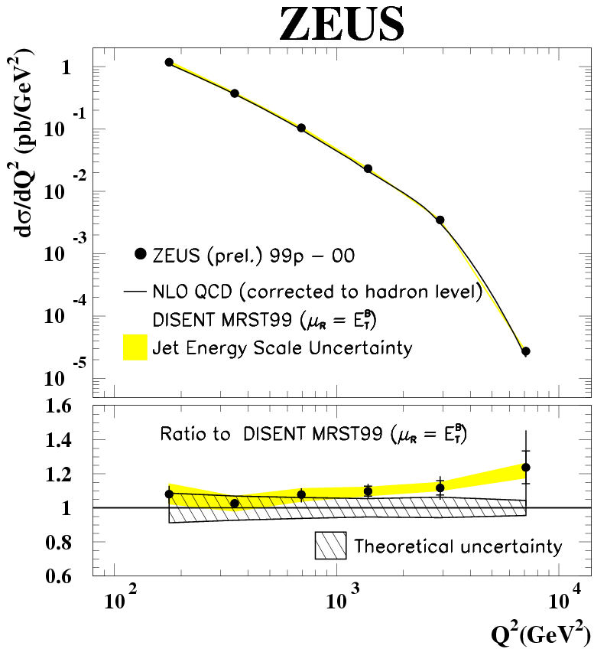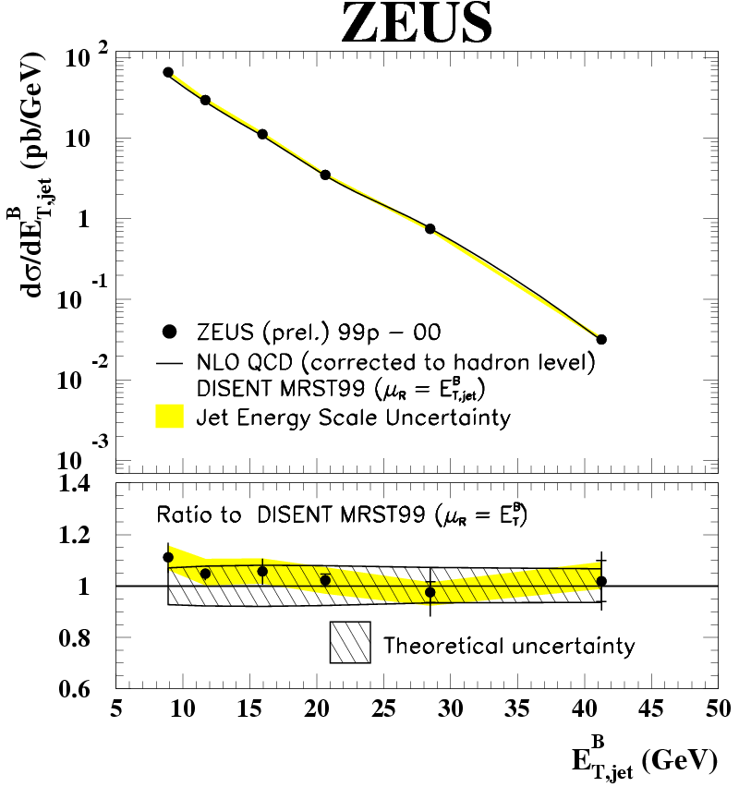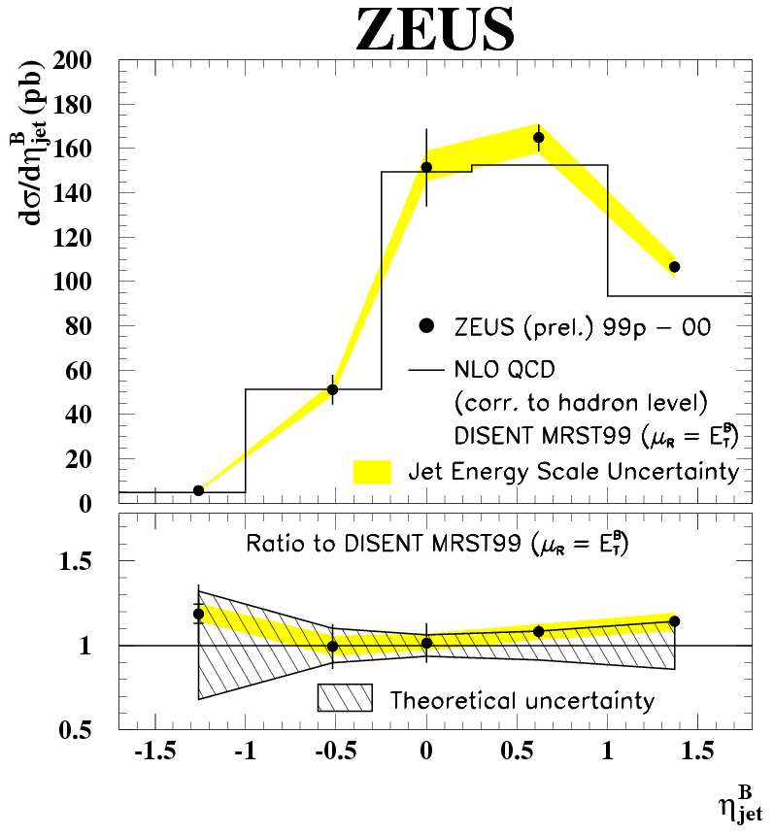
Figure 1. Measured inclusive differential jet cross sections in Q², E_{T}^{B}(jet), η^{B} (upper plots). Lower plots show ratio of measurement to theoretical calculations.

3. Event Selection and Monte Carlo Simulations
Neutral current (NC) deep inelastic scattering (DIS) events were selected from data collected with the ZEUS detector during 1999-2000 when HERA operated with protons of 920 GeV and positrons of 27.5 GeV. An isolated high energy positron was required (E’ > 10 GeV) in the final state and cuts made using the uranium-scintillator calorimeter and central tracking detectors to reject charged current events and beam-gas and cosmic background. Kinematic variables were reconstructed using the angles of the scattered positron and the hadronic system [7]. The hadronic angle, γ_{h}, which corresponds to the direction of the outgoing struck quark in the quark-parton model, was reconstructed from the calorimeter measurement of the hadronic final state.
The jet search was made from the calorimeter cell deposits (excluding those assigned to the scattered positron) in the Breit frame using the longitudinally invariant inclusive k_{T}-cluster algorithm.
Events selected for the measurement satisfied Q² > 125 GeV² and -0.7 < cosγ_{h} < 0.5 and jets were selected to satisfy E_{T}^{B} > 8 GeV and -2.0 < η^{B} < 1.8.
Monte Carlo simulations were used to correct the data for detector acceptance, resolution and efficiency. Two MC models were used to generate DIS events; ARIADNE v4.0 [8] and LEPTO v6.5 [9]. ARIADNE uses the colour-dipole model (CDM) [10] and LO QCD diagrams to simulate the QCD cascade. LEPTO, which was used as a systematic check, uses the exact matrix elements to generate the hard subprocess and parton shower algorithms to simulate higher order processes. Both models use the LUND string model [11] of JETSET v7.4 [12] for the hadronization of the final state. To take into account first-order electroweak corrections, ARIADNE and LEPTO were both interfaced to HERACLES v4.6 [13] using the DJANGO v1.10 [14] program. The response of the ZEUS detector was simulated using a program based on the GEANT 3.13 package [15]. Simulated events were passed through the same selection process as the data.
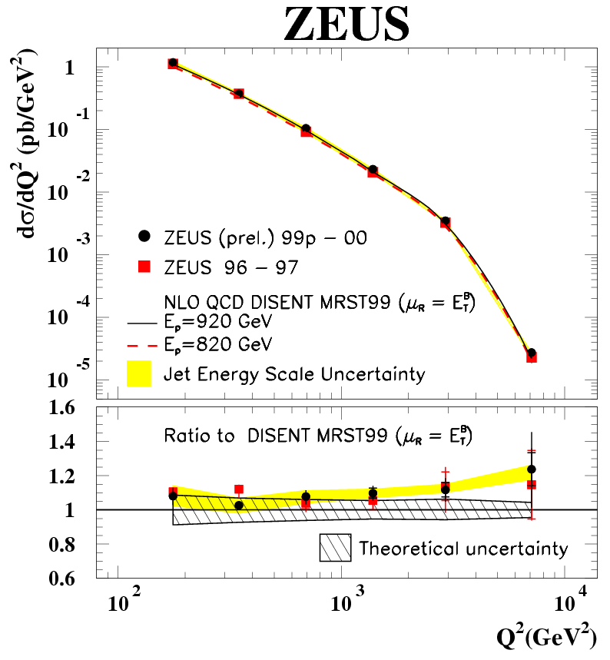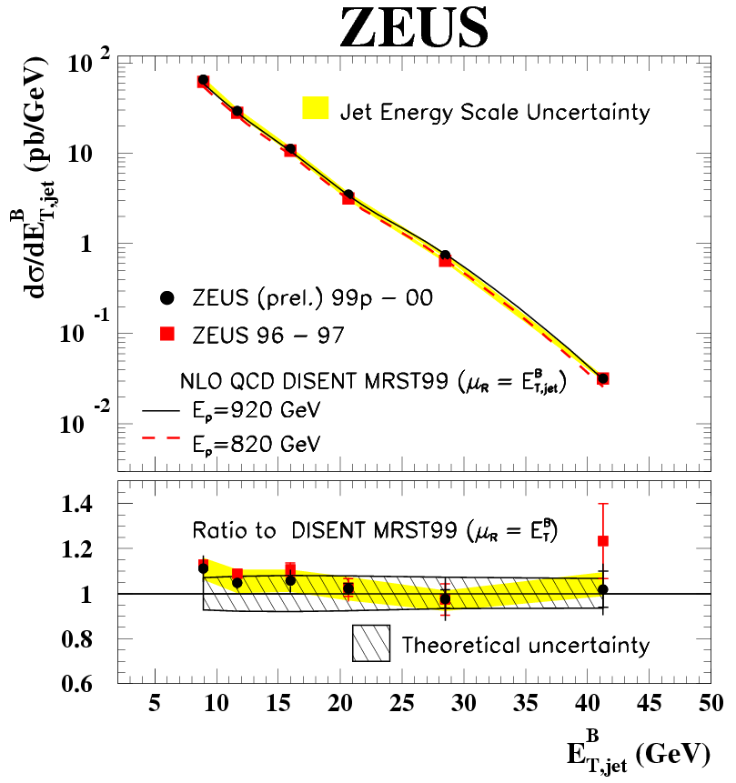
Figure 2. Comparison with previously published results. Measured inclusive differential jet cross sections in Q², E_{T}^{B}(jet) (upper plots). Lower plots show ratio of measurement to theoretical calculations.

4. Results
The inclusive jet differential cross sections as a function of Q², E_{T}^{B}(jet) and η^{B}(jet) are shown in Figure 1. In the top part of the plots the data (corrected to the hadron level and for first-order electroweak effects) are compared to NLO QCD calculations (corrected for hadronization effects). The lower part of the plots shows the ratio of data to the NLO QCD calculations. The hashed band indicates the theoretical error. For all three distributions the data is described well by the theory. The solid band indicates the uncertainty in jet energy scale.
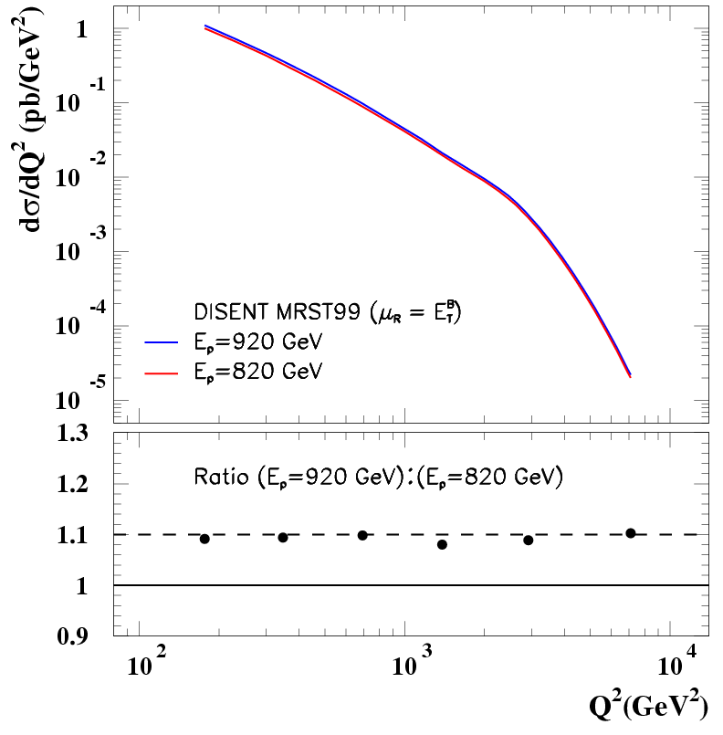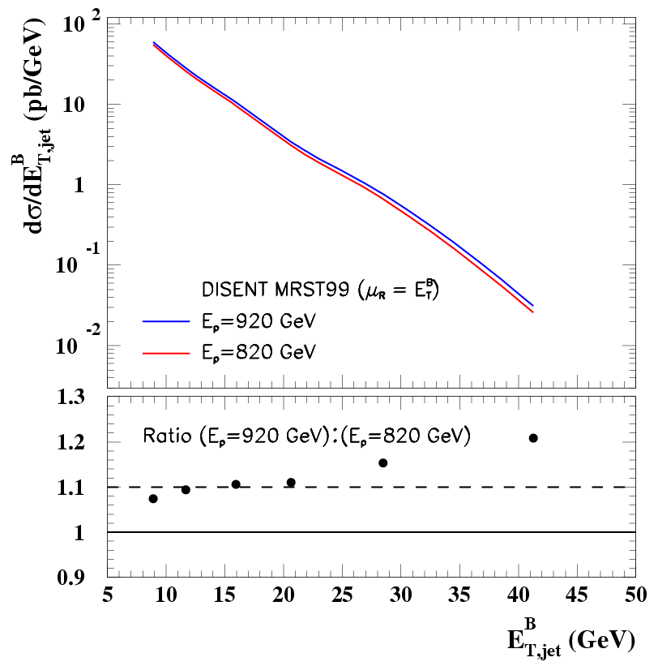
Figure 3. Comparison of theoretical calculations. Inclusive differential cross sections in Q², E_{T}^{B}(jet) (upper) for E_{P} = 820 (920) GeV. Lower plots show ratio of calculations with E_{P} = 820 to E_{P} = 920 GeV.
Figure 2 shows the same distributions for Q² and E_{T}^{B}(jet) directly compared with equivalent distributions from a former ZEUS analysis done for lower proton energy (E_{P} = 820 GeV). It can be seen that there is comparable agreement between data and theory for both analyses. The reduced statistical uncertainties in the new measurement are clearly visible.
Figure 3 shows the effect of the increased beam energy on the NLO QCD predictions for Q² and E_{T}^{B}(jet) inclusive differential jet cross sections. For the Q² distribution the effect of the increased beam energy is to increase the differential cross section by ~10% consistently across the range calculated. For the E_{T}^{B}(jet) distribution, this enhancement itself increases relatively with rising E_{T}^{B}(jet).

I would like to thank the members of the ZEUS collaboration who helped with this research.

References
1. ZEUS Collaboration, S. Chekanov et al., Phys. Lett B 560 (2003) 7; 558 (2003) 41; 531 (2002) 9.
ZEUS Collaboration, S. Chekanov et al., Eur. Phys. J. C 31 (2003) 149; 23 (2002) 615; 23 (2002) 13.
H1 Collaboration, A. Aktas et al., Eur. Phys. J. C 33 (2004) 477; 29 (2003) 497; 25 (2002) 13; 19 (2001) 289.
H1 Collaboration, C. Adloff et al., Phys. Lett. B 542 (2002) 193.
2. S. Bethke, Nucl. Phys. Proc. Suppl. 121 (2003) 74.
3. ZEUS Collaboration, S.Chekanov et al., DESY-05-050 (March 2005), submitted to Eur. Phys. J.
4. S. Catani et al., Nucl. Phys. B 406 (1993) 187.
5. S. Catani and M.H. Seymour, . Phys. B 485 (1997) 291; Erratum in Nucl. Phys. B510 (1998) 503.
6. A.D. Martin et al., Eur. Phys. J. C 4 (1998) 463; 14 (2000) 133.
7. S. Bentvelsen, J. Engelen and P. Kooijman, Proc. Workshop on Physics at HERA; W. Buchmüller and G. Ingelman (eds.), Vol. 1, p. 23, Hamburg, Germany, DESY (1992).
8. L. Lönnblad, Comp. Phys. Comm. 71 (1992) 15; Z. Phys. C 65 (1995) 285.
9. G. Ingelman, A. Edin and J. Rathsman, Comp. Phys. Comm. 101 (1997) 108.
10. Y. Azimov et al, Phys. Lett. B 165 (1985) 147;
G. Gustafson, Phys. Lett. B 175 (1986) 453; 306 (1988) 746;
B. Andersson et al., Z. Phys. C 43 (1989) 625.
11. B. Andersson et al., Phys. Rep. 97 (1983) 31.
12. T. Sjöstrand, Comp. Phys. Comm. 39 (1986) 347;
T. Sjöstrand and M. Bengtsson, Comp. Phys. Comm. 43 (1987) 367.
13. A. Kwistkowski, H. Spiesberger and H.-J. Möhring, Comp. Phys. Comm. 69 (1986) 155.
14. K. Charchula, G.A. Schuler and H. Spiesberger, Comp. Phys. Comm. 81 (1994) 381.
15. R. Brun et al., GEANT3, Technical Report CERN-DD/EE/84-1, CERN, 1987.

